H.K& Kln Kaifong Women’s Association Sun Fong Chung College
Thursday Dictation 2017-2018 First Semester
S1 B

Name: ____________________________________________ Class: ___________ ( )
Different types of sentence patterns used in Form 1:
1. For description（形容）:
(a) ( … know… + noun / noun phrase )
Old Stone Age people knew how to make fire.
2. For definition（定義）:
(a) (... refer to … + noun/noun phrase )
Weather refers to climate conditions over a short period of time.
(b) ( … means… + noun/noun phrase )
The nucleus means the centre of a cell.
(c) (… be known as… )
The increase in the world’s temperature is known as global warming.
3. For cause and effect （因果關係）:
(a) (… leads to …+ noun/noun phrase)
Clearing of forests leads to global warming.
(b) ( … cause… + noun / noun phrase )
Flooding may cause loss of life and injury to people.

*Noun phrase 短語 / 短句
Access：http://sunfc.edu.hk for the READ ALOND version
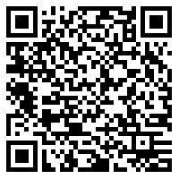  Scan this QR-Code and select the relevant dictation. | 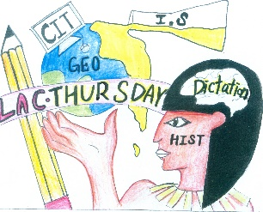  Click this icon on the home page.  Select the relevant dictation.

Date | Subjects | Vocabulary and sentences
 | I.S  Passage 1/  CIT Passage 2  https://quizlet.com/_3lfiiz  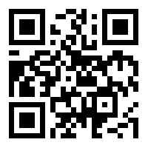 | Vocabulary  - alternative (替代的)  - source (來源)  - nuclear power (核能發電)  - tidal power (潮汐能發電)  - output device (輸出設備).  - input device (輸入設備)  - scanner (掃描器)  - image (圖像)  Sentences  - Wind power (風力發電) is an alternative source of energy.  - Solar energy (太陽能發電) is an alternative source of energy.  - We can use a scanner (掃描器) to input images to the computer.  - A hard disk (硬盤) is a storage device (存儲設備).  - A RAM (隨機存取記憶體) is a storage device.

 | I.S  Passage 3/  History  Passage 4  https://quizlet.com/_3lfiqm  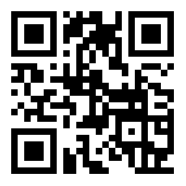 | Vocabulary  - sweat (流汗)  - healthier (更健康)  - hydrated (有水份)  - dehydrated (脫水)  - robber (強盜)  - treasure (金銀財寶)  - spirit (靈魂)  - underworld (地獄)  Sentences  - When we sweat, we will be thirsty (口渴).  - When we are dehydrated, we will need to drink water.  - The First Egyptian king was buried (埋葬) in pyramids (金字塔).  - Rich Egyptians were buried (埋葬) with valuable (貴重的) things.  - The tombs (墓) were decorated (裝飾) with wall paintings.

